What is Cloud Computing?

Cloud computing is the on-demand delivery of compute power, database storage, applications,and other IT resources through a cloud services platform via the internet with pay-as-you-go pricing.

Types of Cloud Computing

Cloud computing has three main types that are commonly referred to as Infrastructure as a Service (IaaS), Platform as a Service (PaaS), and Software as a Service (SaaS). Selecting the right type of cloud computing for your needs can help you strike the right balance of control and the avoidance of undifferentiated heavy lifting

Infrastructure as a Service (IaaS):

Infrastructure as a Service, sometimes abbreviated as IaaS, contains the basic building blocks for cloud IT and typically provide access to networking features, computers (virtual or on dedicated hardware), and data storage space. Infrastructure as a Service provides you with the highest level of flexibility and management control over your IT resources and is most similar to existing IT resources that many IT departments and developers are familiar with today.

### Platform as a Service (PaaS):

Platforms as a service remove the need for organizations to manage the underlying infrastructure (usually hardware and operating systems) and allow you to focus on the deployment and management of your applications. This helps you be more efficient as you don’t need to worry about resource procurement, capacity planning, software maintenance, patching, or any of the other undifferentiated heavy lifting involved in running your application.

### Software as a Service (SaaS):

Software as a Service provides you with a completed product that is run and managed by the service provider. In most cases, people referring to Software as a Service are referring to end-user applications. With a SaaS offering you do not have to think about how the service is maintained or how the underlying infrastructure is managed; you only need to think about how you will use that particular piece software. A common example of a SaaS application is web-based email where you can send and receive email without having to manage feature additions to the email product or maintaining the servers and operating systems that the email program is running on.

## Cloud Computing Deployment Models

### [Cloud:](https://aws.amazon.com/what-is-cloud-computing/)

A cloud-based application is fully deployed in the cloud and all parts of the application run in the cloud. Applications in the cloud have either been created in the cloud or have been migrated from an existing infrastructure to take advantage of the [benefits of cloud computing](https://aws.amazon.com/what-is-cloud-computing/). Cloud-based applications can be built on low-level infrastructure pieces or can use higher level services that provide abstraction from the management, architecting, and scaling requirements of core infrastructure.

### [Hybrid:](https://aws.amazon.com/hybrid/)

A hybrid deployment is a way to connect infrastructure and applications between cloud-based resources and existing resources that are not located in the cloud. The most common method of hybrid deployment is between the cloud and existing on-premises infrastructure to extend, and grow, an organization's infrastructure into the cloud while connecting cloud resources to internal system.

### On-premises:

Deploying resources on-premises, using virtualization and resource management tools, is sometimes called “private cloud”. On-premises deployment does not provide many of the benefits of cloud computing but is sometimes sought for its ability to provide [dedicated resources](https://aws.amazon.com/enterprise/private/).  In most cases this deployment model is the same as legacy IT infrastructure while using application management and virtualization technologies to try and increase resource utilization.

What is AWS?

Amazon Web Services (AWS) is a secure cloud services platform, offering compute power, database storage, content delivery and other functionality to help businesses scale and grow. Explore how millions of customers are currently leveraging AWS cloud products and solutions to build sophisticated applications with increased flexibility, scalability and reliability.

The AWS Cloud provides a broad set of infrastructure services, such as computing power, storage options, networking and databases, delivered as a utility: on demand, available in seconds, with pay-as-you-go pricing

A Global Platform

The AWS Cloud is available in 190 countries, through 13 geographic Regions, 35 Availability Zones, and over 50 local Points of Presence. Build applications which span the globe, or choose to maintain data sovereignty in compliance with your regulatory needs. Compared to other cloud computing companies, the global footprint of AWS is second to none.

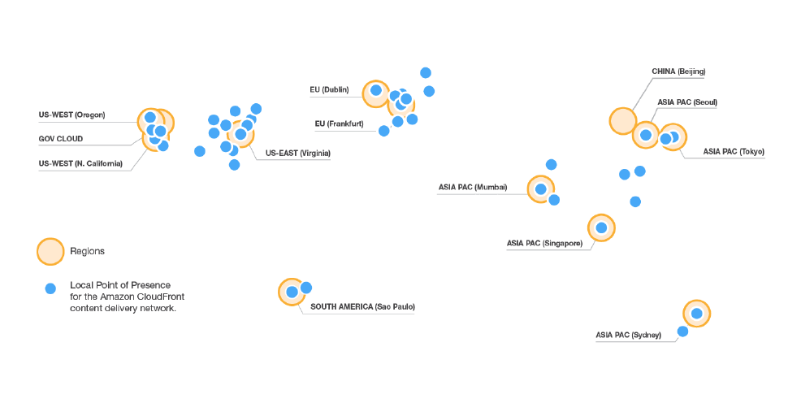

AWS Free Tier

The Amazon Web Services (AWS) Free Tier is designed to enable you to get hands-on experience with AWS Cloud Services.

The AWS Free Tier includes services with a free tier available for 12 months following your AWS sign-up date, as well as additional service offers that do not automatically expire at the end of your 12 month AWS Free Tier term.

After creating your AWS account you can use any of the products and services, listed below, for free within certain usage limits.